CASE STUDY 2 Progressive Electricity Billing
- Problem Statement
Calculate a household electricity bill from units consumed using progressive slabs, a fixed charge, and a surcharge when consumption is high.
2. Objectives
Use input, variables, arithmetic operators, and conditional statements.
Calculate charges across multiple consumption slabs.
Display a readable bill summary.
3. Assumptions
First 100 units cost ₹1.50 per unit.
Next 100 units (101–200) cost ₹2.50 per unit.
Units above 200 cost ₹4.00 per unit.
Fixed charge is ₹50; consumption above 250 units attracts a 5% surcharge on energy charges.
4. Algorithm
1. Read units consumed.
2. Reject negative units.
3. Calculate energy charge using the three progressive slabs.
4. Add the fixed charge.
5. If units exceed 250, add a 5% surcharge on energy charges.
6. Display the energy charge, surcharge, and total.
5. Flowchart
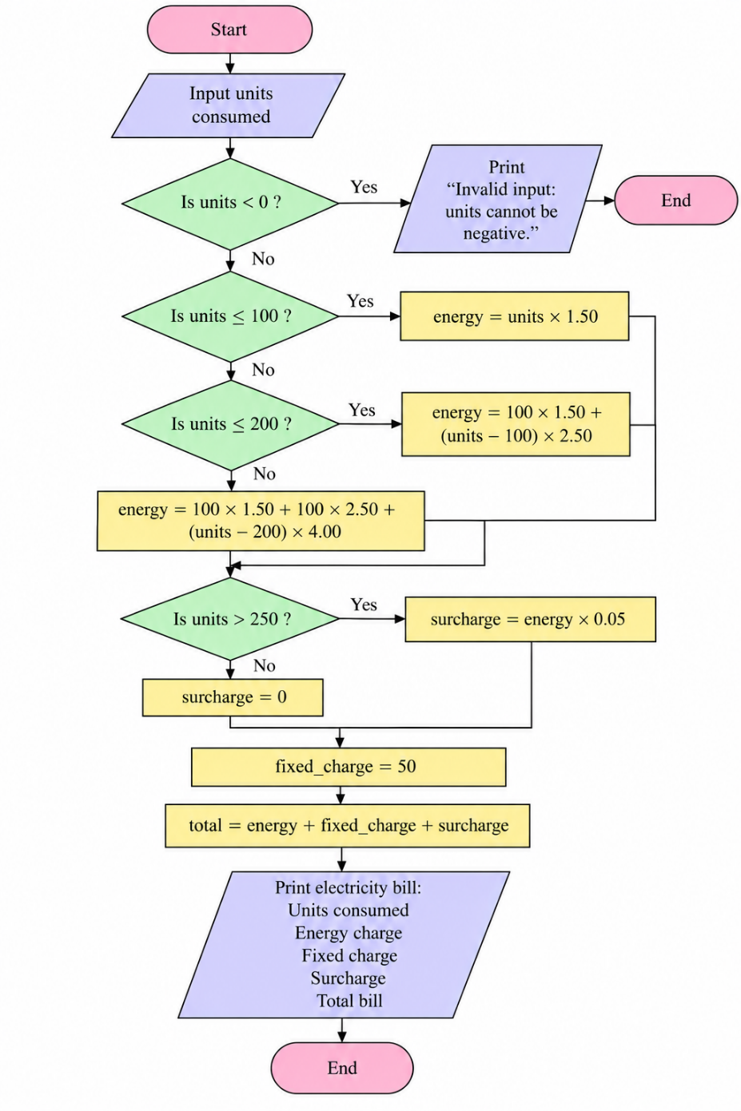
6. Pseudocode
START
INPUT units
IF units < 0: PRINT invalid; STOP
IF units <= 100: energy = units * 1.50
ELSE IF units <= 200: energy = 100*1.50 + (units-100)*2.50
ELSE: energy = 100*1.50 + 100*2.50 + (units-200)*4.00
surcharge = energy*0.05 IF units > 250 ELSE 0
total = energy + 50 + surcharge
PRINT bill details
END
7. Test Cases
Test | Input / Scenario | Expected result
1 | 80 | Energy ₹120.00; surcharge ₹0.00; total ₹170.00
2 | 150 | Energy ₹275.00; surcharge ₹0.00; total ₹325.00
3 | 300 | Energy ₹850.00; surcharge ₹42.50; total ₹942.50
4 | -5 | Invalid input message
8. Output Screenshot
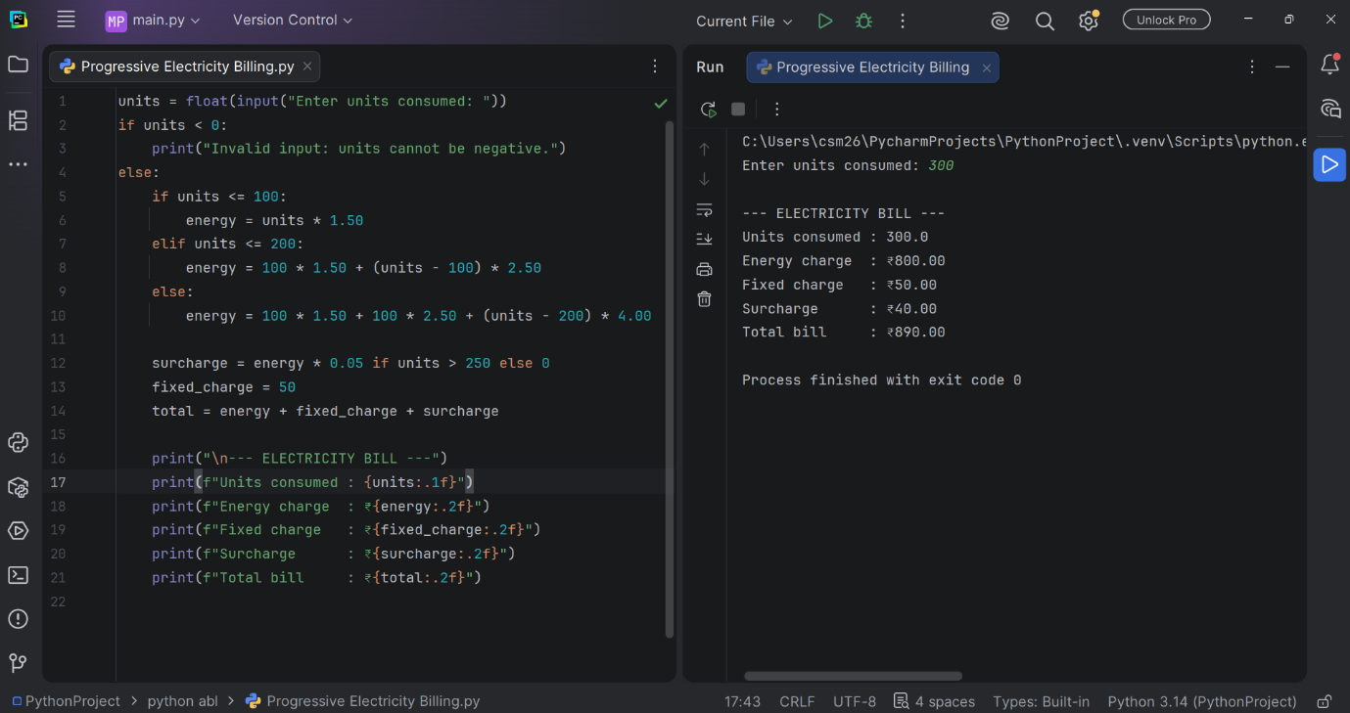
9. Conclusion
The program calculates an electricity bill using progressive slabs and applies a surcharge only when the stated threshold is crossed.

